CprE 419 Lab 7:

Pig User Defined Functions for analyzing stock data

**Shuo Wang**

**Exp1:** Find the largest growth factor for each stock and report the top 5 stock with largest growth rate.

For finding the largest growth factor for each stock:

**Idea:** The largest growth factor is the highest the price divided by the lowest price in the analyzing period, subject to: the lowest price has to happen before the largest price

**Note:** The price of the last available day over the price of the first available day may not give the largest growth factor. For example, part of the records for ticker “HOT” is like this:

|  |  |  |
| --- | --- | --- |
| HOT | 20000103 | 23.38 |
| HOT | 19971024 | 55.21 |
| HOT | 19920527 | 0.42 |
| HOT | 19900102 | 5.02 |

the largest growth factor is 55.21/042 = 131.45 rather than 23.38/5.02 = 4.66.

“Hot” with growth factor 131.45 is the top 1 ticker during period Jan 1st, 1990 – Jan 3rd, 2000.

**Algorithm:** sort the records by time for a certain ticker; scan from the first day to the last day while tracking the minimum price seen so far; calculate the growth rate by current price over minimum price; update the growth rate by the largest growth rate so far while scanning; report the growth rate after the scan.

For the detailed algorithm please refer to the Java source code in the submission file.

**Output:** the output for experiment 1 is shown below

Period Jan 1st, 1990 – Jan 3rd, 2000.

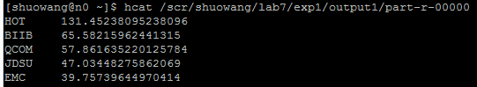

Period Jan 2nd, 2005 – Jan 31st, 2014.

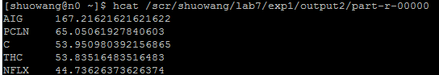

**Exp2:** Find the moving average for six companies.

For the detailed algorithm please refer to the Java source code in the submission file.

Part of the output for experiment 2 is shown below

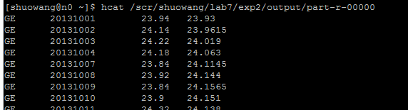

For the entire output for experiment 2 please refer to the text file in the submission file.

**Appendix: files in submission .zip**

1. exp1.pig and exp2.pig are pig file for running in n0

2. GROWTH.java is the Java source code of UDF for exp1.pig and GROWTH.jar is the compiled file

3. MOVAVG.java is the Java source code of UDF for exp2.pig and MOVAVG.jar is the compiled file

4. exp1_output.txt and exp2_output.txt are the output results for experiment 1 and 2, respectively